Task for today:

==============

1) Setup jenkins CICD pipeline using freestyle job using below code.

https://github.com/betawins/hiring-app.git

Stages:

1. Git Clone

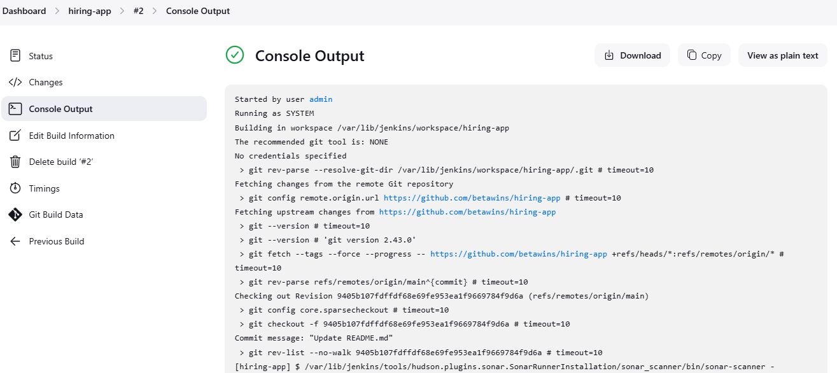

1. Sonarqube Integration

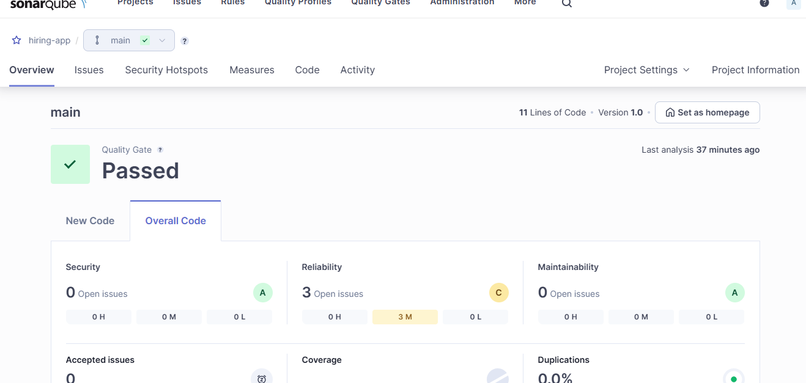

1. Maven Compilation

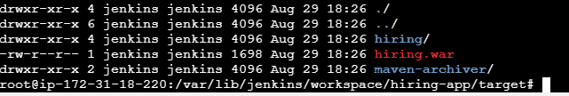

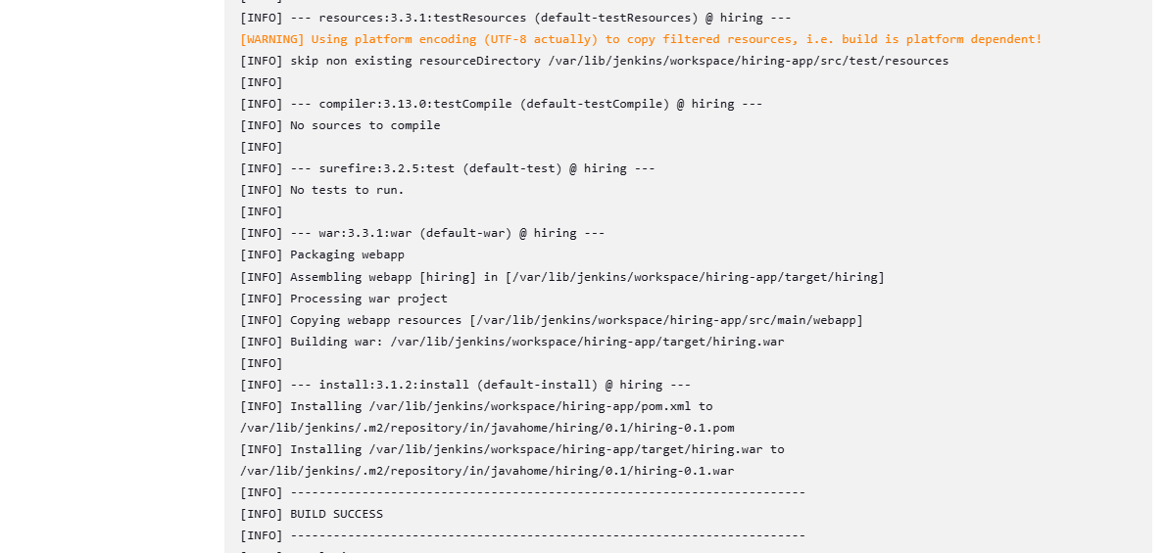

1. Nexus Artifactory

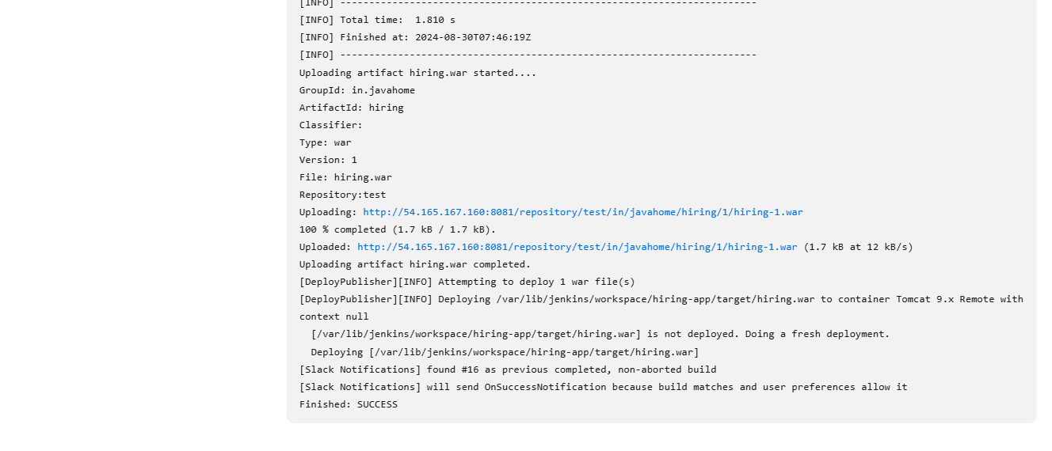

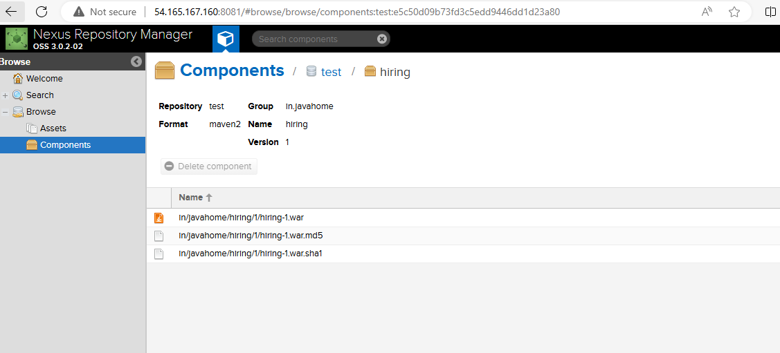

1. Slack Notification



1. Deploy On tomcat

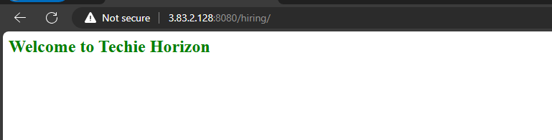

2) Setup jenkins job using freestyle job using below code.

https://github.com/betawins/Techie_horizon_Login_app.git

Stages:

1. Git Clone:

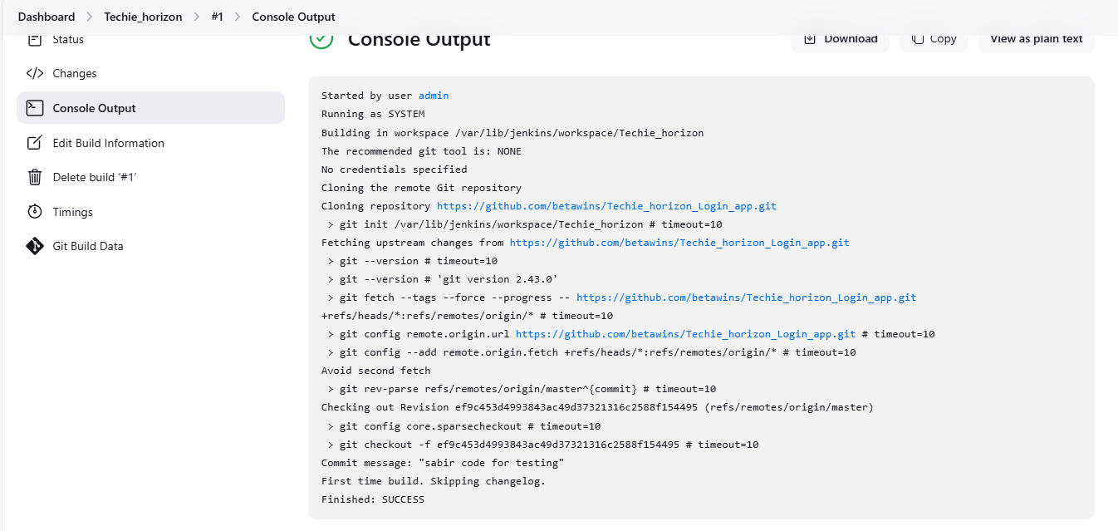

1. Sonarqube Integration

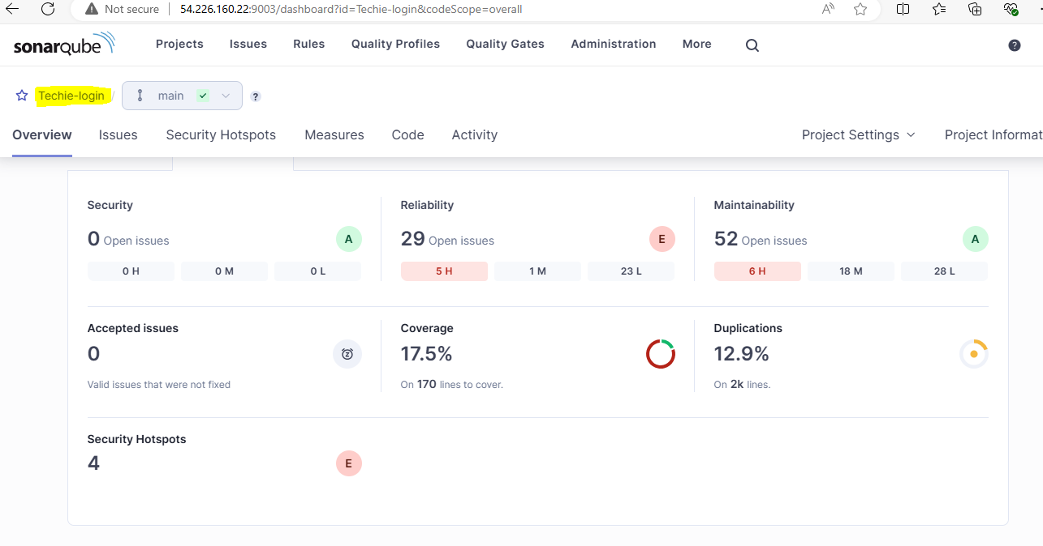

1. Maven Compilation

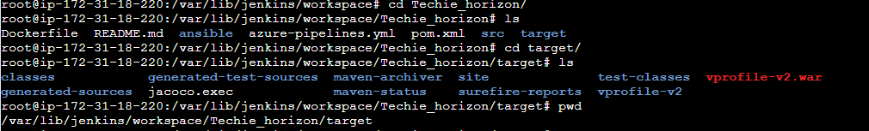

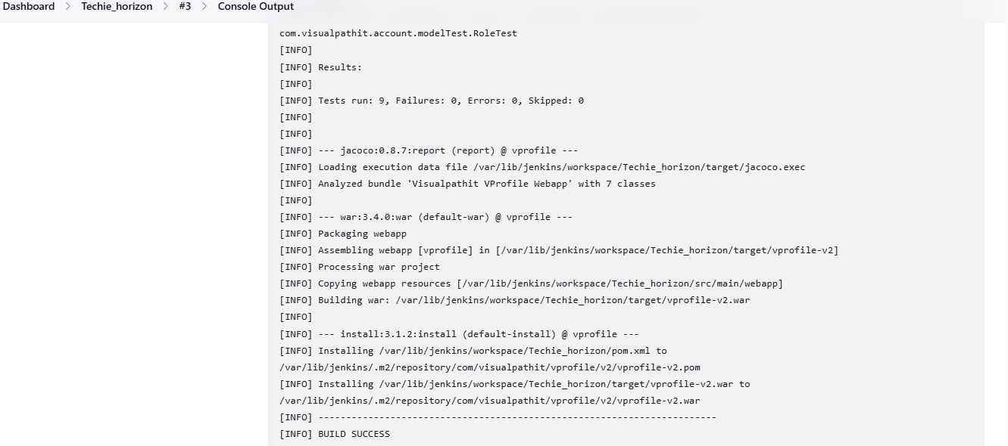

1. Nexus Artifactory

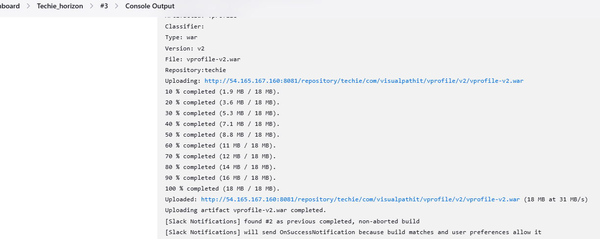

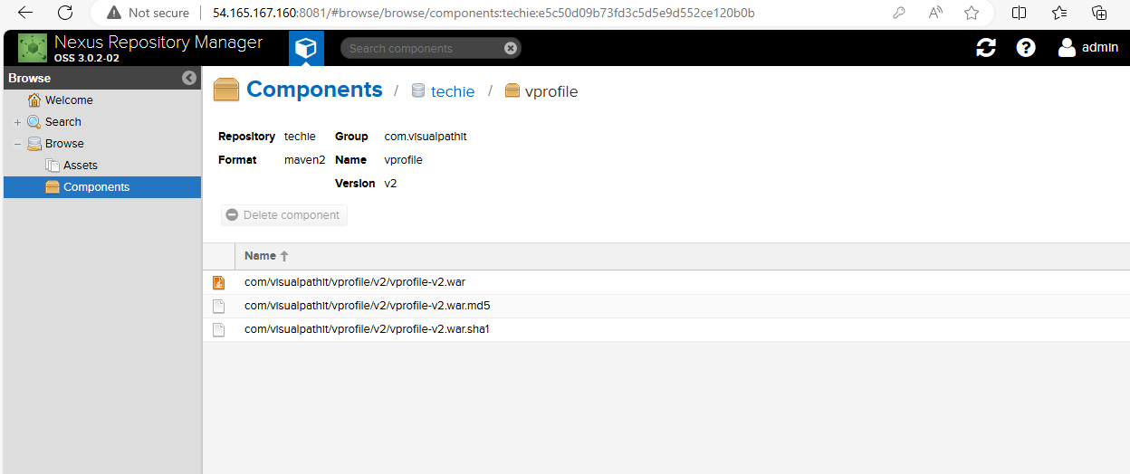

1. Slack Notification

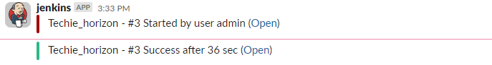

1. Deploy On tomcat

